directives: Please use this document to write your paper and do not change its format;
- Full paper should not exceed 5 pages;
- Font is Times New Roman;
- Words of paragraphs in the text are typed in 12 points;
- Single line spacing;
- 06 points spacing must be left above and below any heading, caption, figure, table and equation.

3rd Scientific Days of Innovation:
22 – 23 October 2019
University of Biskra



(please write your title here)
First Author^{1*}, SecondAutor², Third Author³….(Full names are required)

¹ Affiliation, address(different affiliations must be listed in separate lines)
² Affiliation, address
³ Affiliation, address

*Corresponding Author Email:xxxxxxxxxx

short Description:
Please write a short description (200-300 words) about your project, mentioning mainly: Its properties and/or operating principle, its uses, its estimated costs…etc.

TABLES & FIGURES(If needed should be designed as mentioned below)

Tables
Example:
Table 1. xxxxxxxxxx

Table | Xxxx | xxxx
xxxx | Xxxx | xxxx

Figures
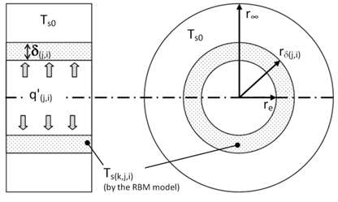
Fig. 1.Axial and radial views of the pipe
REFERENCES (if needed)

Please number all the references with Arabic numerals in square brackets, such as [1], [14], [23].Please use the examples bellow to organizeyour references:
[1] M. Philippe, M. Bernier and D. Marchio, Validity ranges of three analytical solutions to heat transfer in the vicinity of single boreholes, Geothermics, vol.38 (4), pp. 407-413, 2009.
[2] M. N. Özisik, Heat conduction: second ed., John Wiley & Sons, New York, 1993.
[3] A. Rouag, A. Benchabane, A. Labed and N. Boultif, "Use of shallow geothermal energy to improve the efficiency of air heat exchangers: Proposal of a Geothermal Air-Cooler (GAC)"Utilisation de la géothermie très basse énergie pour l’amélioration de l’efficacité des échangeurs de chaleur à air : Proposition d'un aéro-refroidisseur géothermal, DZ Patent 9045,Algeria, 2014.
[4] A. Labed, N. Moummi, M. Zellouf, K. Aoues and A. Rouag. Effect of Different Parameters on the Solar Drying of Henna; Experimental Investigation in the Region of Biskra (Algeria). Presented In Progress in Clean Energy, vol.2, pp. 979-992, 2015.

